Dispensation Letter

To:
{place}

Dear Sir/Madam,
We, the organising committee of Garuda Hacks 7.0, a major technology competition hosted by Garuda Hacks, would like to inform you that {participant_name} will be participating as a competitor in Garuda Hacks 7.0, which will be held on:
Date: 16-18 July, 2026
Venue: Universitas Multimedia Nusantara (UMN)
In light of this event, we respectfully request that the aforementioned student be granted dispensation from academic activities during the above-mentioned dates to allow him to attend and compete in the competition.

We sincerely appreciate your understanding and support.
Best regards,
Garuda Hacks 7.0 Organising Committee
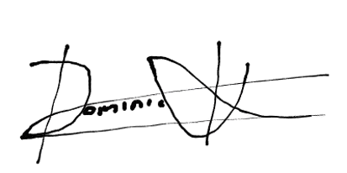
Dominic Moreno Kartadjoemena
Signed: {date_of_sending}

